Johns Hopkins University

Project 3

Serial Transmit of Temperature

Miles Gapcynski

EN.605.715.81.FA19 - Software Development for Real-Time Systems

Professor Doug Ferguson

09/29/2019

Contents

Derived Requirements 3

Hardware Design 4

Board Layout 5

Software Design and Implementation 6

Sequence Diagrams 6

Results 7

Video Demonstration 8

# Derived Requirements

The following requirements were derived from the Project 3 Measurement and transmission of propeller speed v1 document:

* The system shall measure the speed of a brushless propeller using an IR Emitter/Detector pair.
* The system shall capture the propeller’s RPMs using an interrupt driven by the IR Emitter/Detector pair.
* The system shall record the propeller RPMs over time.
* The system shall transmit the propeller RPMs across Serial (USB) to a host machine.
* The system shall utilize a DC motor and the system shall be capable of changing the DC motor’s RPM over time.

# Hardware Design

The following diagram is a schematic of the circuit connected to an Arduino Uno (rev. 3) that will calculate the rotations per minute of a motor using an IR emitter and detector pair. The IR signal is blocked by a propeller attached to a DC motor, and an ISR is triggered on a falling edge when this happens due to the pull-up resistor. The Mosfet transistor closes the DC motor’s circuit whenever the digital pin goes high, thus powering the DC motor. The DC motor’s speed is controlled using pulse width modulation (PWM), and the PWM value is controlled by a potentiometer. The potentiometer’s value is read by an analog pin (10 bits) and mapped to the PWM range (8 bits).



# Board Layout

The following picture showcases how the hardware design was implemented using an Arduino Uno (rev. 3) and breadboard:

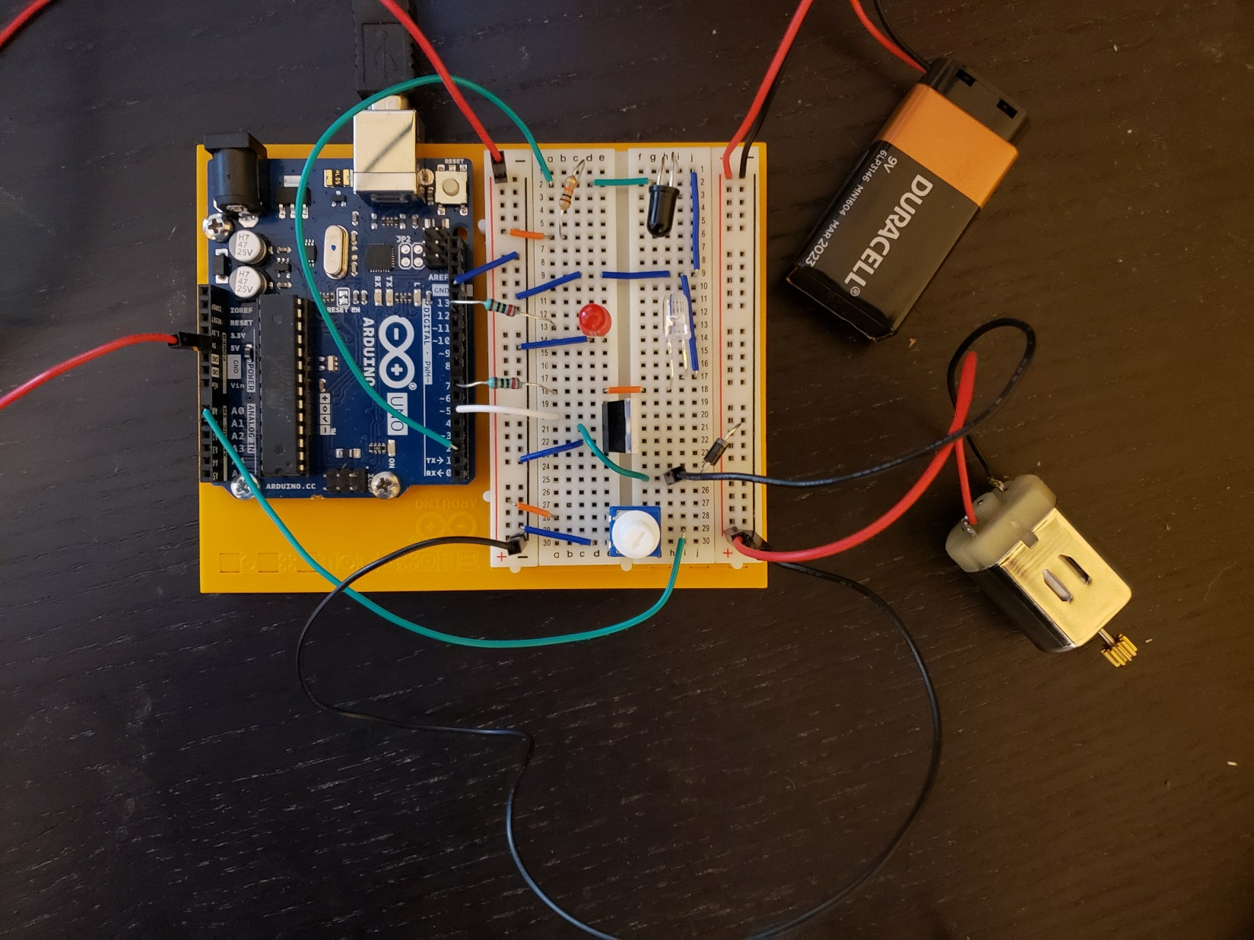

# Software Design and Implementation

## Sequence Diagrams

The following diagram is a sequence diagram of the program that calculates the rotations per minute of a motor and outputs the RPM value over Serial (USB) to a host machine:



# Results

The following plot was generated from the RPM values output from the Arduino to the host machine over Serial (USB) during the video demonstration. The DC motor speed was increased from 0 to full speed in several steps, and then the DC motor speed was continuously decreased back down to 0.

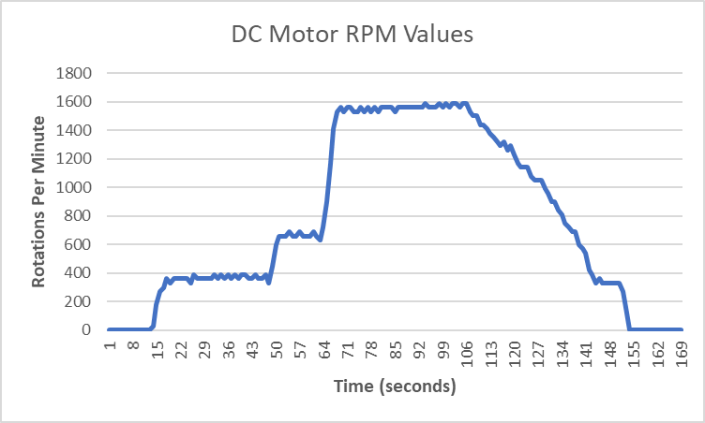

# Video Demonstration

A video demonstration of the software and Arduino running can be found at the following link:

<https://www.youtube.com/watch?v=YIQ1LjnNjT0&t=6s>

<https://www.dropbox.com/s/qwcri81rh4t5gks/Miles_Gapcynski_EN_605_715_81_Project_3.mp4?dl=0>